AI ASSISTANT CODING
ASSIGNMENT – 6.5
NAME : B . Manali Reddy
HT.NO : 2303A52187
BATCH : 34
Task Description #1 (AI-Based Code Completion for Conditional Eligibility Check) Task: Use an AI tool to generate eligibility logic. Prompt: “Generate Python code to check voting eligibility based on age and citizenship.” Expected Output: • AI-generated conditional logic. • Correct eligibility decisions. • Explanation of conditions.
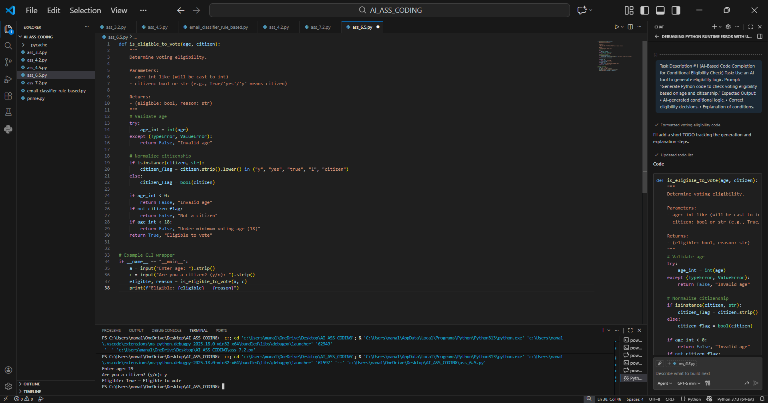
Task Description #2(AI-Based Code Completion for Loop-Based String Processing) Task: Use an AI tool to process strings using loops. Prompt: “Generate Python code to count vowels and consonants in a string using a loop.” Expected Output: • AI-generated string processing logic. • Correct counts. • Output verification.
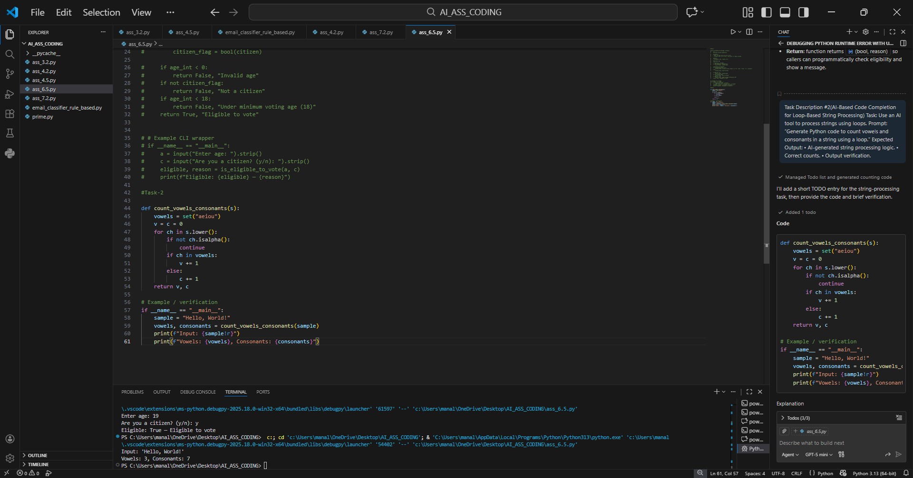
Task Description #3 (AI-Assisted Code Completion Reflection Task) Task: Use an AI tool to generate a complete program using classes, loops, and conditionals. Prompt: “Generate a Python program for a library management system using classes, loops, and conditional statements.” Expected Output: • Complete AI-generated program. • Review of AI suggestions quality. • Short reflection on AI-assisted coding experience.
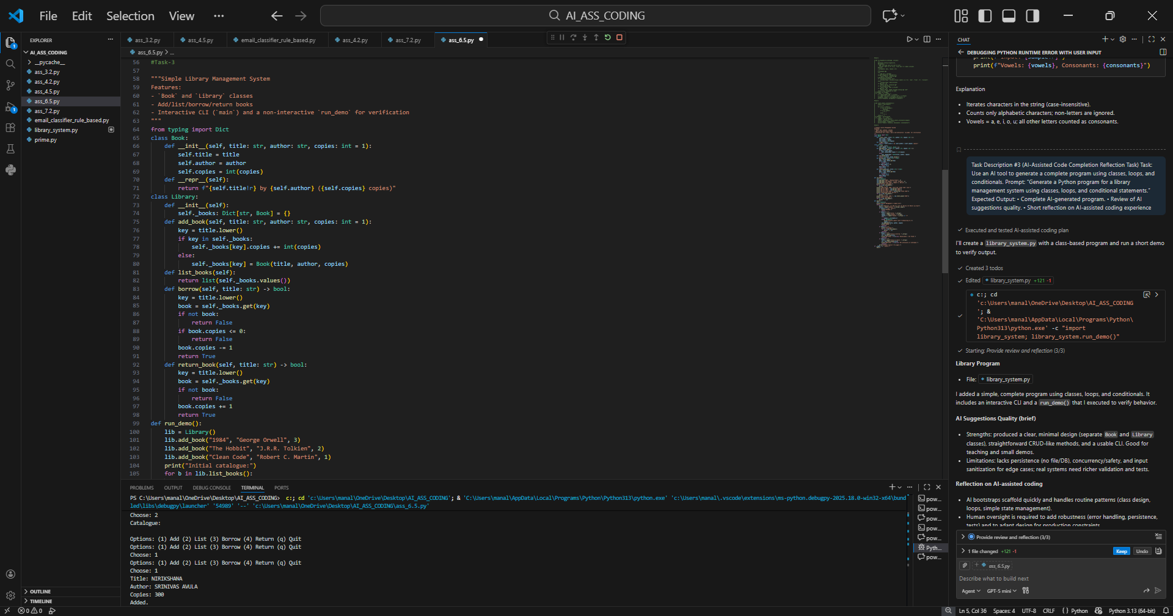
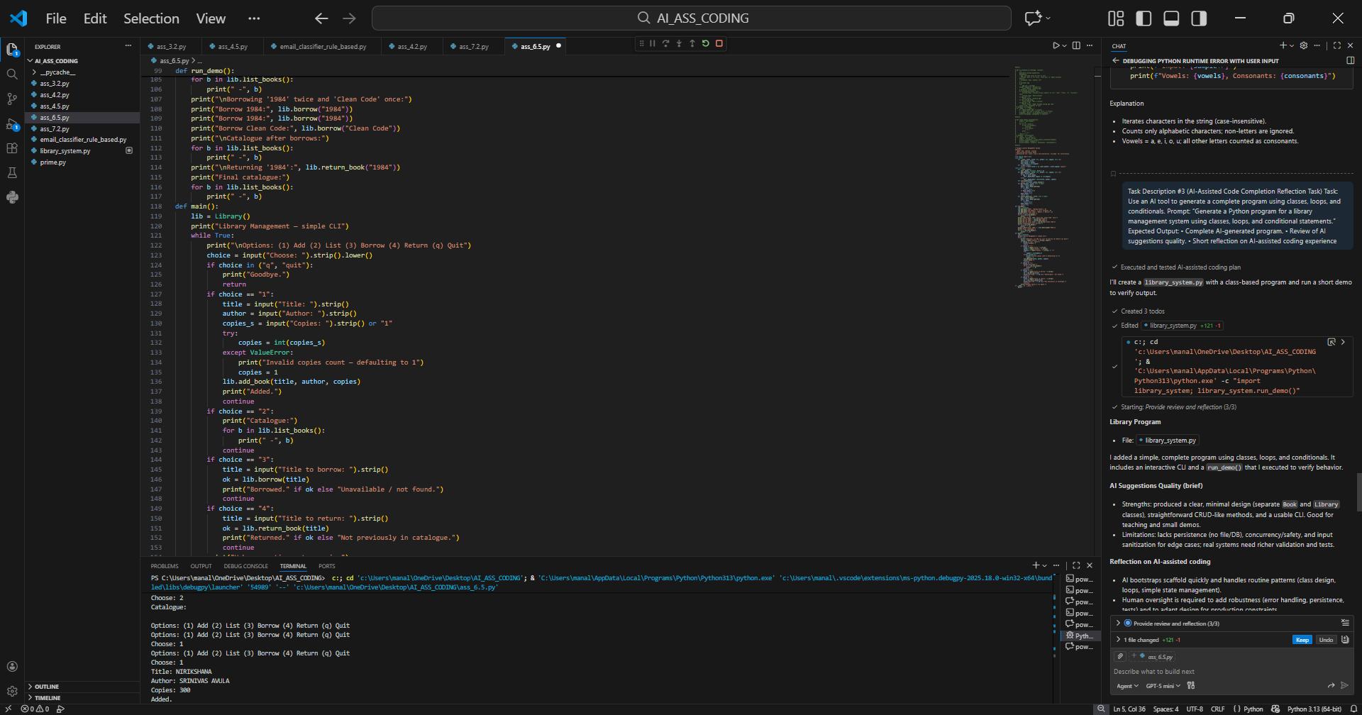
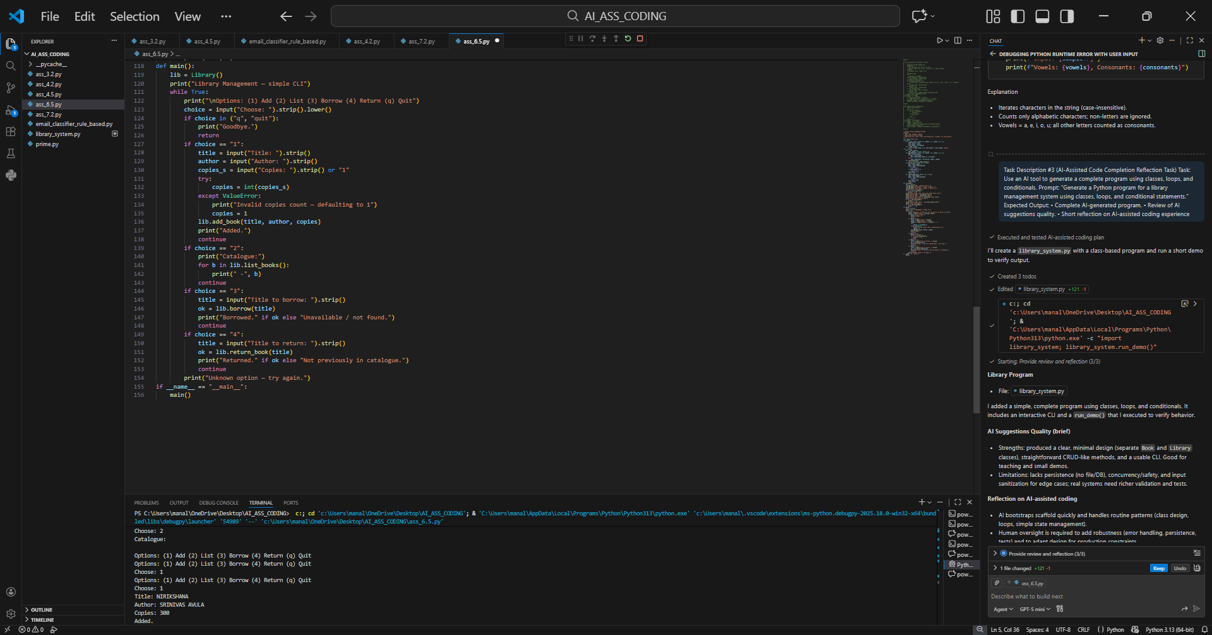
Task Description #4 (AI-Assisted Code Completion for Class- Based Attendance System) Task: Use an AI tool to generate an attendance management class. Prompt: “Generate a Python class to mark and display student attendance using loops.” Expected Output: • AI-generated attendance logic. • Correct display of attendance. • Test cases.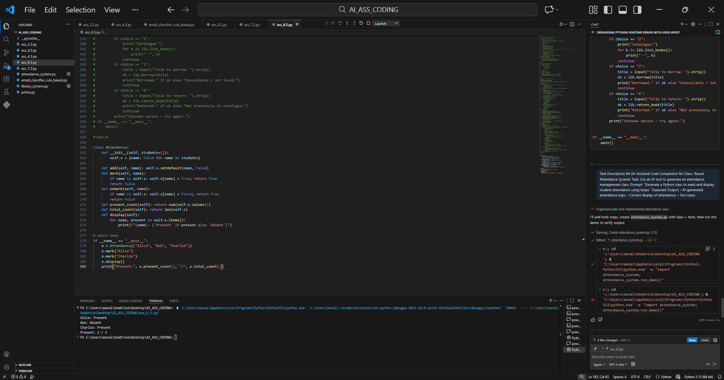
Task Description #5 (AI-Based Code Completion for Conditional
Menu Navigation)
Task: Use an AI tool to complete a navigation menu.
Prompt: “Generate a Python program using loops and conditionals
to simulate an ATM menu.”
Expected Output:
• AI-generated menu logic.
• Correct option handling.
• Output verification.
